**Community Clean-Up Event**

**Rosemont Neighborhood**

Sponsored by Sacramento County Supervisor, Don Nottoli – District 5  
and Code Enforcement

**August 17th, 2019**, from 8:00 a.m. to noon. **RAIN OR SHINE!!!!**

(Map on Back – Unincorporated Sacramento County Residents ONLY)

Residents and the County are joining together to spruce up the neighborhood by removing junk and rubbish and cutting back overgrown vegetation. The County will provide coordination, collection bins and staffing. This is a free service to community residents.

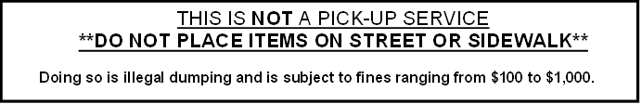

**Accepted Items for removal:**

* **Rubbish**: sofas, particle board, laminate counter tops, hardware, ceramics, old toys, small plastic appliances, carpet, toilets, furniture, keyboards, water softeners, plastic items
* **Metal Items**: stoves, washers, dryers, barbeques (NO ashes or tanks), water heaters, dishwashers, small metal appliances, lawn furniture (NO vinyl), bicycles, drained lawn mowers (NO gas or oil), refrigerators, air conditioning units
* **Wood:** lumber, fencing, tree logs, yard waste unable to fit in county green waste can.

(NO palm)

* **Tires:** limit 4 passenger car tires per household (NO truck tires)
* **E-Waste**: Televisions, computer monitors/towers, laptops (NO batteries).

**Prohibited Items:**

Recyclables, wet household garbage, or hazardous waste or painted, varnished, chemically treated or pressure treated wood, including rail road ties. We have the right to refuse any items that do not meet the criteria for the clean-up.

**Additional Information:**

* + - Flyer **must** be shown to the traffic and bin monitors; be prepared to show picture I.D. with current address
    - Long lines may be expected at either bin site. Participants may be redirected to an alternate site.
    - **Do NOT place items outside the bins or at the bin sites before they arrive—any illegal dumping will be subject to citation**
    - Be prepared to open all garbage bags for the bin monitors—**Clear bags are preferred**
    - **First Come, First Served**

**Community Clean-Up Event**

**Rosemont Neighborhood**

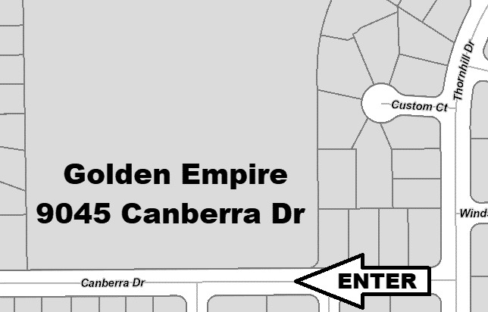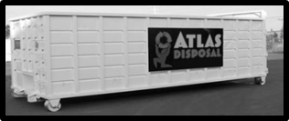**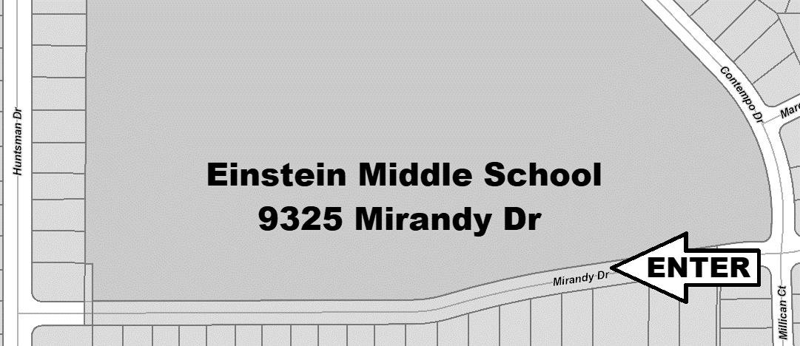****August 17th, 2019**

Services

Provided by:

ATLAS DISPOSAL

**Bin Site #2 Location:**

**Golden Empire Elementary**

**9045 Canberra Dr**

**Enter from Thornhill Dr**

**Bin Site #1 Location:**

**Einstein Middle School**

**9325 Mirandy Dr**

**Entrance at Contempo**

**\*WATCH FOR SIGNS AT EACH SITE FOR APPROPRIATE ROUTE\***

If you currently have an active *CODE ENFORCEMENT* case on your property, this is an opportunity to dispose of junk and rubbish and help keep your neighborhood clean. Please note that we will not be accepting material from haulers or other contractors during this project.

For further information or if you need assistance removing items from your property due to physical limitations and need to schedule an appointment, call Code Enforcement Officer Rosa Orellana (916-874-3658), **no later than noon on August 14th, 2019**.

**Note:** ***One (1) small truck load per pickup appointment. Items in excess are your responsibility to dispose of.***

*Residents may encounter detours or minor traffic delays near the bin sites.